**EV 3 Robot**

**Starting the project:**

* Using LeJOS
* Familiarise with Github and Git (REQUIRED)
  + Must be able to check out an old working version and built on demand.
* Familiarise with LATEX. (REQUIRED documentation software)
* Familiarise with Ant (REQUIRED build system)
* Test code tool such as Junit (REQUIRED) – Have testing manager, but each group must contribute to a test case.
* Decide on code coverage tool such as EMMA, COBERATURA (REQUIRED).
* Decide on code text editor, Sublime Text, Eclipse, Atom, IntelliJ, and etc.
* Decide on IDE such as Eclipse.
* Decide on a software documentation for code, JavaDoc, Doxygen, etc.
* Decide on a software process
  + Waterfall
  + Prototyping
  + Incremental
  + Agile
  + Spiral

**Progression: needs to be documented weekly and be saved in versions with the source code**

* Create milestones (time is budget) using timesheets
* Each member to create timesheet to show what you will be working on and when, then combine them so that resources can be allocated as a group.
* Have an agenda for every meeting with the clients, prepare things that needs to be discovered and possibly prototypes for them to experiment.
* Produce Software Requirements specification, Software Process Management plan and software design document. (We need to know the capabilities and constraints of the robot in order to produce specific and accurate requirements)
* Produce test cases; input, expected outcomes, actual outcomes, etc.

**Ending the project:**

* Verify contributions of the project for each member
* Assessing your peers regarding their contribution to the project

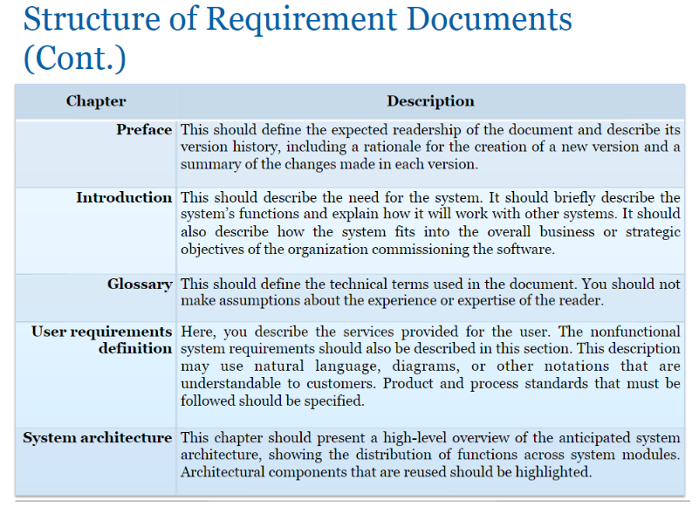

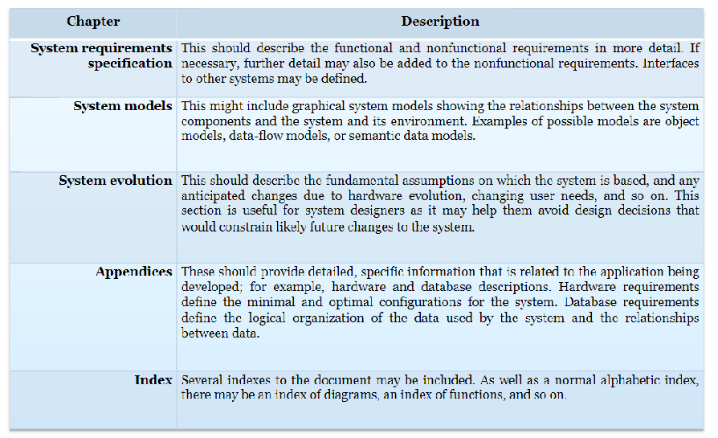

* Bounding Box of 500 meters in landing site.
* Maximum speed of rover? Average speed?  
  how fast can the EV3 go in order to consistently detect debris and creators correctly?
* What if some remnants are identified outside of bounding box?  
   Go to them?   
   Ignore?
* Precise measurements? What kind? Coordinations? Measurement from the main point of bounding box?
* How to go about exploring the area?
* What needs to be shown in survey map?  
   Debris and crates?  
   Needs to be high quality, zoomable